# A PROJECT ON

**Home Services Management System**

SUBMITTED IN

PARTIAL FULFILLMENT OF THE REQUIREMENT

FOR THE COURSE OF DIPLOMA IN ADVANCED COMPUTING FROM CDAC



#### SUNBEAM INSTITUTE OF INFORMATION TECHNOLOGY

Hinjawadi

**SUBMITTED BY:**

Joshi Abhilash Dinesh

Alind Dwivedi

Arya Patil

Sudhanshu Singh

**UNDER THE GUIDANCE OF:**

Pooja Jaiswal

Faculty Member

Sunbeam Institute of Information Technology, Pune

ACKNOWLEDGEMENT

A project usually falls short of its expectation unless aided and guided by the right persons at the right time. We avail this opportunity to express our deep sense of gratitude towards Mr. Nitin Kudale (Center Coordinator, SIIT, Pune) and Mr. Yogesh Kolhe (Course Coordinator, SIIT ,Pune) .

We are deeply indebted and grateful to them for their guidance, encouragement and deep concern for our project. Without their critical evaluation and suggestions at every stage of the project, this project could never have reached its present form.

Last but not the least we thank the entire faculty and the staff members of Sunbeam Institute of Information Technology, Pune for their support.

Joshi Abhilash Dinesh

Alind Dwivedi

Arya Patil

Sudhanshu Singh

83884 PG-DAC

83876 PG-DAC

83888 PG-DAC

83782 PG-DAC

SIIT Pune

# INTRODUCTION TO PROJECT

This project focuses on the development of a Home Services Management System, a system designed to streamline the process of booking and managing home maintenance services.

In the modern era, the demand for efficient home service solutions has grown exponentially. The convenience of scheduling, managing such services online has become a necessity for many. This project aims to address this need by creating a user-friendly system that connects customers with service providers, offering a variety of home services ranging from simple cleaning tasks to complex repairs.

The system will be developed with a focus on ease of use, efficiency, and reliability. It will include features such as a service catalogue, a scheduling system, user support mechanism and a feedback mechanism . The project will also consider the perspectives of service providers, incorporating a vendor portal that allows for the management of services. This initiative is poised to deliver a significant contribution to the market by offering a service that addresses the requirements of both consumers and service providers effectively. The anticipated outcome is a platform that stands as a testament to the power of technology in transforming everyday tasks and services.

**2.REQUIREMENTS**

**2.1 FUNCTIONAL REQUIREMENTS**

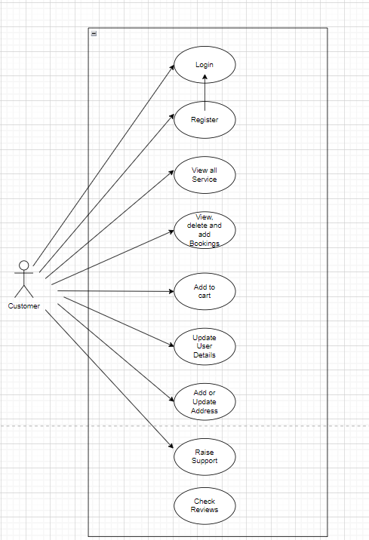

**2.1 User Account**

The Home Services Management system provides a range of functionalities to manage user accounts, encompassing registration, authentication, password updates, and address management. The core features include user registration, where individuals can create new accounts by providing an email, password, and other personal details. It is crucial that the passwords match during registration for account creation to proceed successfully. User authentication enables users to log in by submitting their email and password, after which a JWT token is issued. This token facilitates secure access to protected resources and subsequent user-specific data requests.

Password management allows users to update their passwords, provided their email matches an existing account. Additionally, users can retrieve detailed information about themselves, update personal details, and manage their addresses. Address management includes adding new addresses, retrieving all associated addresses, and fetching or updating specific types of addresses (e.g., home or work). Users can also get their home address formatted as a string. Error handling is implemented to address issues such as invalid data, unauthorized access, or resource not found. The system employs JWT tokens for secure authentication, encrypts passwords for protection, and validates all input data to prevent security vulnerabilities like SQL injection.



**2.2 Registration and creation of user profile**

User registration is the initial step for new users to create an account within the system, enabling them to access protected features and services. The process involves submitting a registration request with essential details such as email, password, and personal information (e.g., name, age, phone number). The system performs validations to ensure that the email is unique, the password meets complexity requirements, and that both the password and its confirmation match. If the validation succeeds, the user account is created with encrypted credentials, and a confirmation response is provided. If any validation fails, the system returns an appropriate error message indicating the issue, such as password mismatch or email duplication.

Following registration, users may receive a confirmation email to activate their account, depending on the system's configuration. Upon successful registration, users can log in using their email and password to access their accounts. The process ensures secure handling of user information through encryption and validation, maintaining data integrity and protection against unauthorized access.

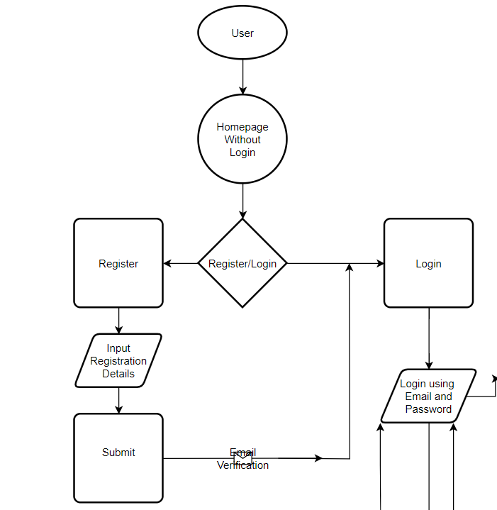

* 1. **Add Or Update Address**

Adding or updating an address within the User Account Management system provides users with the flexibility to manage their address information accurately and efficiently. To add a new address, users must provide detailed address information, including street, house number, city, state, country, and postal code. This request is made through a form or interface, and it requires authentication via a valid JWT token. The token ensures that only authorized users can add addresses to their account. Once the information is validated and the request is authenticated, the new address is saved and associated with the user's profile.

Updating an existing address involves submitting the updated address details along with a valid JWT token. The system verifies the token to ensure the request is made by an authenticated user and that the address being updated is correctly identified. The address details are then reviewed for accuracy and completeness. Upon successful verification, the system updates the existing address in the user’s account, ensuring that any changes are accurately reflected in the system’s records.

Both adding and updating addresses are crucial for maintaining current and accurate user information. The use of JWT tokens for authentication helps to secure these operations, preventing unauthorized access. Additionally, thorough validation processes ensure that only accurate and complete address information is stored, enhancing the overall integrity and reliability of the user’s address data. This approach ensures users can manage their addresses effectively while safeguarding their personal information.

Top of Form

Bottom of Form

* 1. **Add, Delete and View Bookings**

In the Home Services Management system, managing bookings involves several critical operations: adding, deleting, and viewing bookings. When a user wants to add a booking, they must provide the subcategory ID, the desired date, time, and a valid JWT token for authentication. Additionally, users have the option to select a specific address from their saved addresses to associate with the booking. This address selection ensures that services are scheduled at the correct location. The system verifies the subcategory’s existence and the token’s validity before creating a new booking with a "Pending" status, thereby recording the user’s request and facilitating service scheduling.

To view bookings, users need to provide a valid JWT token. The system then retrieves and displays all bookings associated with the authenticated user, including comprehensive details such as the booking ID, subcategory name, provider ID, booking date, time, rate, status, and the selected address. This detailed view allows users to track their appointments, manage service providers, and review past bookings, including the locations where services are scheduled.

When deleting a booking, users specify the booking ID for cancellation. The system first checks whether the booking exists and if its status is "Assigned." If these conditions are met, an associated order with a "Cancelled" status is created to formally document the cancellation. The booking record is then removed from the system. This process ensures that cancellations are properly managed and any associated services or commitments are addressed before deleting the booking.

Overall, the booking management features enhance user experience by integrating address selection into the booking process, thereby ensuring accurate service delivery. The use of JWT tokens for authentication guarantees secure access to these functionalities, while the careful handling of booking statuses and related entities upholds system integrity and user satisfaction. This comprehensive approach supports effective scheduling and management of services, including precise address handling.

**2.5 View Booking History**

In the Home Services Management system, users can view their past bookings through a detailed overview that includes several essential elements. Each past booking provides comprehensive information about the booking ID, the subcategory of service requested, the provider responsible for fulfilling the request, and the specific date and time of the appointment. Additionally, users can view the rate charged for the service and the current status of the booking, which helps in tracking the progress and completion of services. This information is crucial for users to manage their appointments effectively, ensuring they are aware of past engagements and related details.

Furthermore, the system integrates address details into the booking information, showing the address associated with each booking. This feature helps users review and verify the locations where services were scheduled, enhancing accuracy and convenience. By displaying these details, users can track their service history, manage interactions with service providers, and confirm that services were delivered to the correct addresses. This holistic view of past bookings facilitates better planning and record-keeping for users.

* 1. **Provider flow**

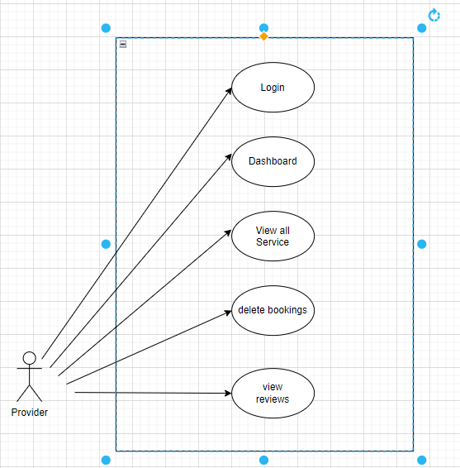

* 1. **Admin flow**

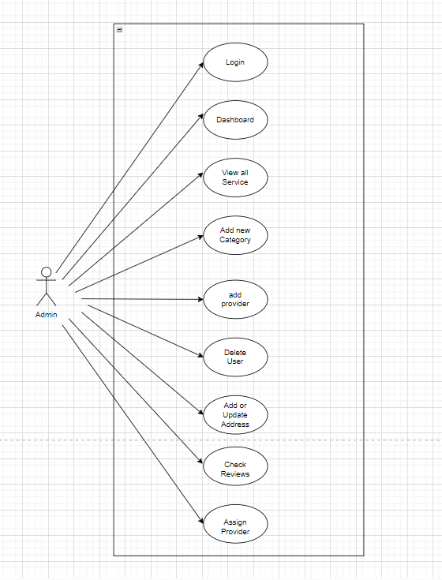

* 1. **NON FUNCTIONAL REQUIREMENTS**

**2.2.1 Interface**

Go to Appendix B for user interfaces

**2.2.2 Performance**

Efficient Booking Management: The system's performance in managing bookings is marked by its ability to handle critical operations such as adding, viewing, and deleting bookings efficiently. When a user adds a booking, the system ensures that all necessary details—such as the subcategory ID, desired date, time, and JWT token—are correctly validated before creating a new booking with a "Pending" status. This process ensures that users can seamlessly schedule services while the system maintains accurate records and verifies all inputs to prevent errors. The integration of address selection further enhances the accuracy of service delivery, ensuring that services are scheduled at the correct location. This efficient management of bookings supports a smooth user experience and reliable service scheduling.

Robust Cancellation Handling: The system excels in handling booking cancellations through a structured approach. When a user requests to delete a booking, the system first verifies the existence of the booking and checks if its status is "Assigned." This validation ensures that only active and valid bookings can be canceled. Once these conditions are met, an associated order with a "Cancelled" status is created to document the cancellation formally. This careful management of cancellations helps in addressing any associated services or commitments before removing the booking record from the system. By documenting cancellations accurately and updating the booking status, the system maintains operationalintegrity and ensures that service providers and users are properly informed of any changes.

**2.2.3 Constraint**

The system imposes strict validation requirements when adding a new booking. Users must provide a valid JWT token, which is essential for authentication. Additionally, the system must validate the existence of the subcategory ID before proceeding with the booking creation. This validation ensures that only valid and authorized bookings are processed. Furthermore, users must select a specific address from their saved addresses, which introduces a dependency on the availability and accuracy of address data. These constraints help maintain the integrity and accuracy of booking data but may introduce complexity and potential points of failure if validation steps are not handled correctly.

**2.2.4 Other Requirements:**

**1. Hardware Compatibility**: The Home Service Management System (SPMS) is designed to operate on hardware with the following specifications:

* **Processor**: The system is expected to function effectively on hardware with an Intel Pentium III 900 MHz processor or an equivalent. This processor speed indicates a relatively low-end requirement, suitable for systems where high performance is not critical but basic functionality must be maintained.
* **RAM**: A minimum of 8GB of RAM is required. This amount of memory is suitable for basic operations and smaller-scale deployments, although more RAM would be beneficial for better performance and handling larger data sets or concurrent users.
* **Storage**: The system requires at least 20 GB of HDD (Hard Disk Drive) storage. This storage capacity accommodates the application’s data, including user information, booking details, and system logs. For better performance, especially with growing data or more extensive user activity, a larger storage capacity may be considered.

1. **System Performance and Suitability**: Given these hardware constraints, the system is designed for relatively modest deployments. The specified hardware interfaces indicate that the application is intended to run on older or less powerful hardware, which may be suitable for small to medium-sized operations or environments with limited resources. For more demanding use cases or higher performance needs, such as handling a large number of concurrent users or processing extensive data, modern hardware with upgraded specifications would be necessary to ensure optimal performance and responsiveness.

**Software Interfaces**

The Home Services Management System shall work on MS Windows operating systems family (MS Windows 98, MS Windows NT Workstation, MS Windows 2000, MS Windows XP). It configures to work with Mysql database. This System works on Apache Tomcat server. It uses browser IE 5.0 & above. It uses IIS 5.0 server.

**3. DESIGN**

**3.1 Database Design**

The following table structures depict the database design.

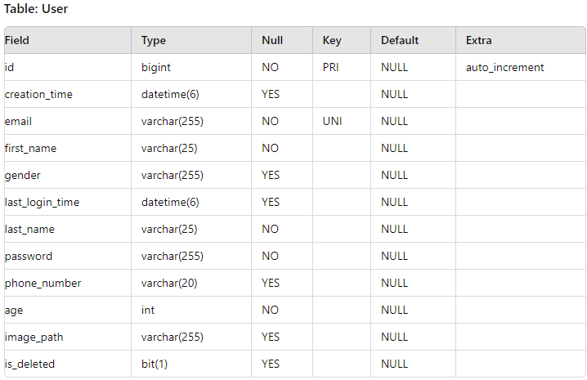

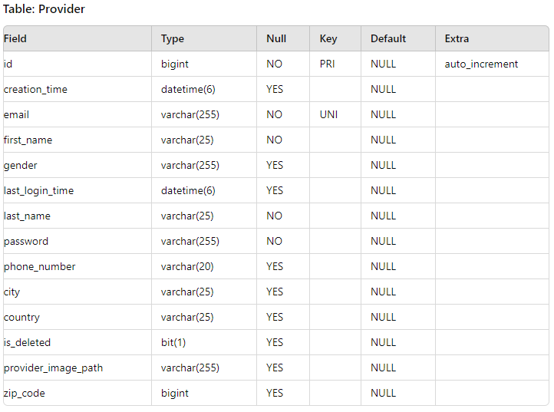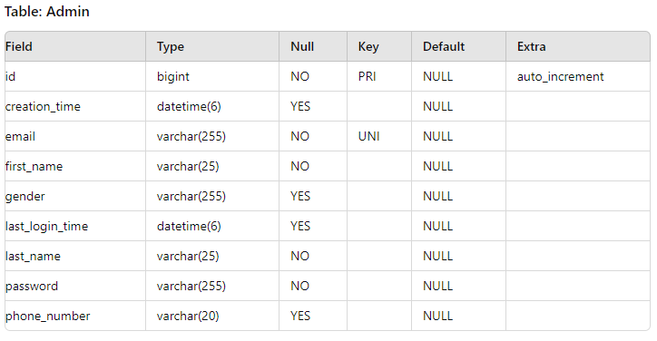

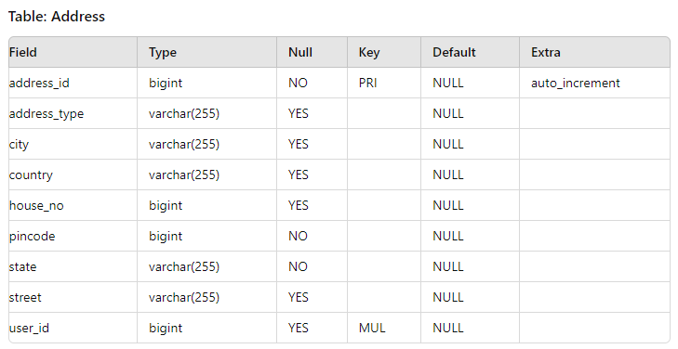 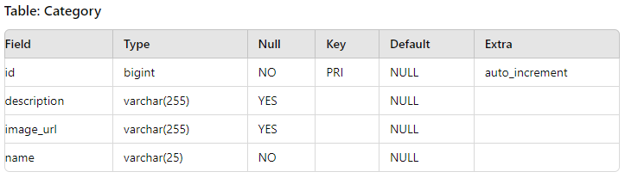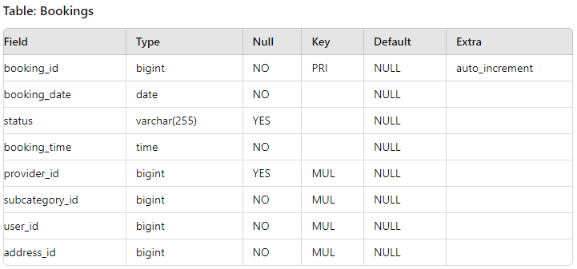

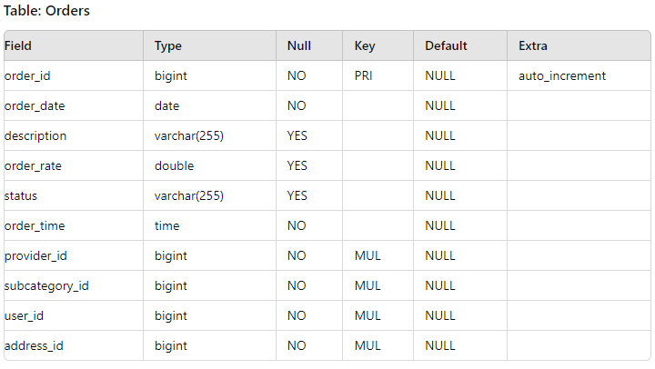 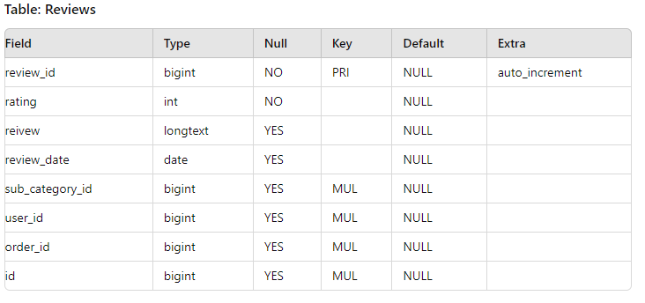 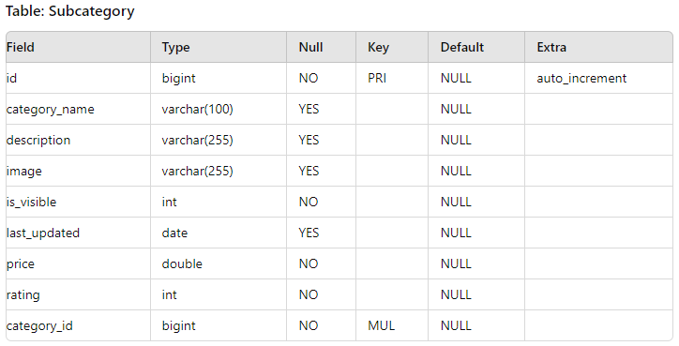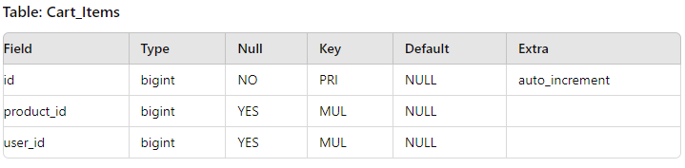

**E-R Diagram,Dataflow diagram and Class Diagram:**

Go to Appendix A

**4. CODING STANDARDS IMPLEMENTED**

### Naming and Capitalization

Below summarizes the naming recommendations for identifiers in Pascal casing is used mainly (i.e. capitalize first letter of each word) with camel casing (capitalize each word except for the first one) being used in certain circumstances.

|  |  |  |  |
| --- | --- | --- | --- |
| **Identifier** | **Case** | **Examples** | **Additional Notes** |
| Class | Pascal | User, Category, SubCategory, Orders | Class names should be based on "objects" or "real things" and should generally be **nouns**. No ‘_’ signs allowed. Do not use type prefixes like ‘C’ for class. |
| Method | Camel | getUser, getBookings | Methods should use **verbs** or verb phrases. |
| Parameter | Camel | firstName, lastName | Use descriptive parameter names. Parameter names should be descriptive enough that the name of the parameter and its type can be used to determine its meaning in most scenarios. |
| Interface | Pascal with "I" prefix | Disposable | Do not use the ‘_’ sign |
| Property | Pascal | ForeColor, BackColor | Use a noun or noun phrase to name properties. |
| Associated private member variable | _camelCase | _foreColor, _backColor | Use underscore camel casing for the private member variables |
| Exception Class | Pascal with "Exception" suffix | ApiException, |  |

### Comments

* Comment each type, each non-public type member, and each region declaration.
* Use end-line comments only on variable declaration lines. End-line comments are comments that follow code on a single line.
* Separate comments from comment delimiters (apostrophe) or // with one space.
* Begin the comment text with an uppercase letter.
* End the comment with a period.
* Explain the code; do not repeat it.

**5. TEST REPORT**

**Another group called Linux did the testing and the report of the testing is given hereunder.**

**GENERAL TESTING:**

|  |  |  |  |  |
| --- | --- | --- | --- | --- |
| **SR-NO** | **TEST CASE** | **EXPECTED RESULT** | **ACTUAL RESULT** | **ERROR MESSAGE** |
| 1 | Register Page | Redirected to Next page | OK | Nothing |
| 2 | Login Page | Pop-up will come | Ok | Please enter username and password again . |
| 3 | Forget Password | Only users password will be reseted | Ok | Nothing |
| 4 | View All service | Gives all Catgeory with SubCategory | Ok | Nothing |
| 5 | View all Booking | Get Current and PastBookings | Ok | Nothing |
| 6 | Checking login or not | User is logged in or not | Ok | Nothing |
| 7 | Add Booking details for Booking Service | Add informations according to time slot | Ok | Nothing |
| 8 | Delete Bookings | Delete Bookings Based On booking id | Ok | Nothing |
| 9 | Add Address in Address table | Save this all data into Address table | Ok | Nothing |
| 10 | Update Address in Address table | Update Address Based On Type of Address selected | Ok | Nothing |
| 11 | Update User Details | It shows you user details and let it Update | Ok | Nothing |
| 12 | Logout | It will logout from user profile. | Ok | Nothing |
|  | **STATIC TESTING** |  |  |  |
| **SR-NO** | **Deviation** | **Program** |  |  |
| 1 | Commenting not followed | All Web Application |  |  |

**6. PROJECT MANAGEMENT RELATED STATISTICS**

|  |  |  |  |
| --- | --- | --- | --- |
| **DATE** | **WORK PERFORMED** | ****SLC Phase**** | **Additional Notes** |
| MAR 12,2024 | Project Allotment and User Requirements Gathering | Feasibility Study | Our team met the client Mr. Nitinkudale (CEO, SIIT Pune) to know his requirements. |
| MAR 29,2024 | Initial SRS Document Validation  And Team Structure Decided | Requirement Analysis  (Elicitation) | The initial SRS was presented to the client to understand his requirements better |
| APR 20,2024 | Designing the use-cases, Class Diagram, Collaboration Diagram, E-R Diagram and User Interfaces | Requirement Analysis &  Design Phase | Database Design completed |
| MAY 10,2024 | Business Logic Component design Started | Design Phase | ---------------------- |
| MAY 29,2024 | Coding Phase Started | Coding Phase | 70% of Class Library implemented. |
| JUN 1,2024 | Implementation of Web Application and Window Application Started | Coding Phase | Class Library Development going on. |
| JUN 2, 2024 | Off | Off | Off |
| JUN 3, 2024 | Implementation of Web Application and Window Application Continued | Coding Phase and Unit Testing | Class Library Modified as per the need. |
| JUN 4, 2024 | Implementation of Web Application and Window Application Continued | Coding Phase and Unit Testing | -- |
| JUL 15, 2024 | After Ensuring Proper Functioning the Required Validations were Implemented | Coding Phase and Unit Testing | Module Integration was done by the Project Manager |
| AUG 5, 2024 | The Project was Tested by the respective Team Leaders and the Project Manager | Testing Phase (Module Testing) | -- |
| AUG 10, 2024 | The Project was Submitted to Other Project Leader of Other Project Group For Testing | Testing Phase (Acceptance Testing) | The Project of Other Team was Taken up by the Team for Testing |
| AUG 11-14, 2024 | The Errors Found were Removed | Debugging | The Project was complete for submission |
| AUG 16, 2024 | Final Submission of Project |  |  |

**User Flow Diagram:**

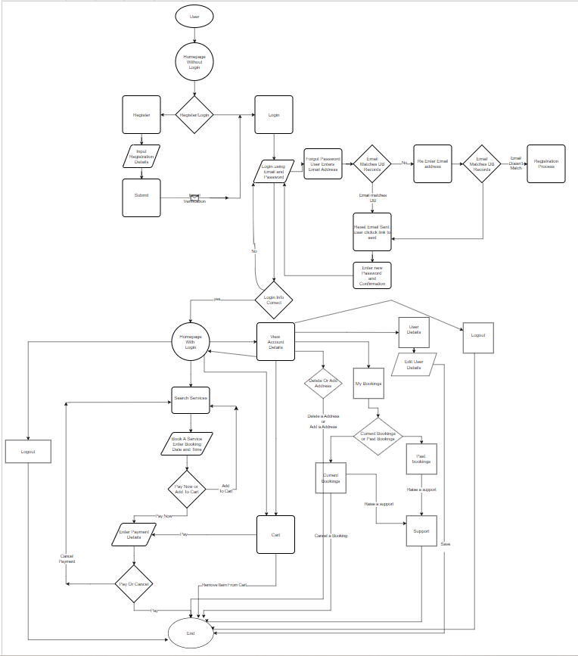

**Class Diagram**

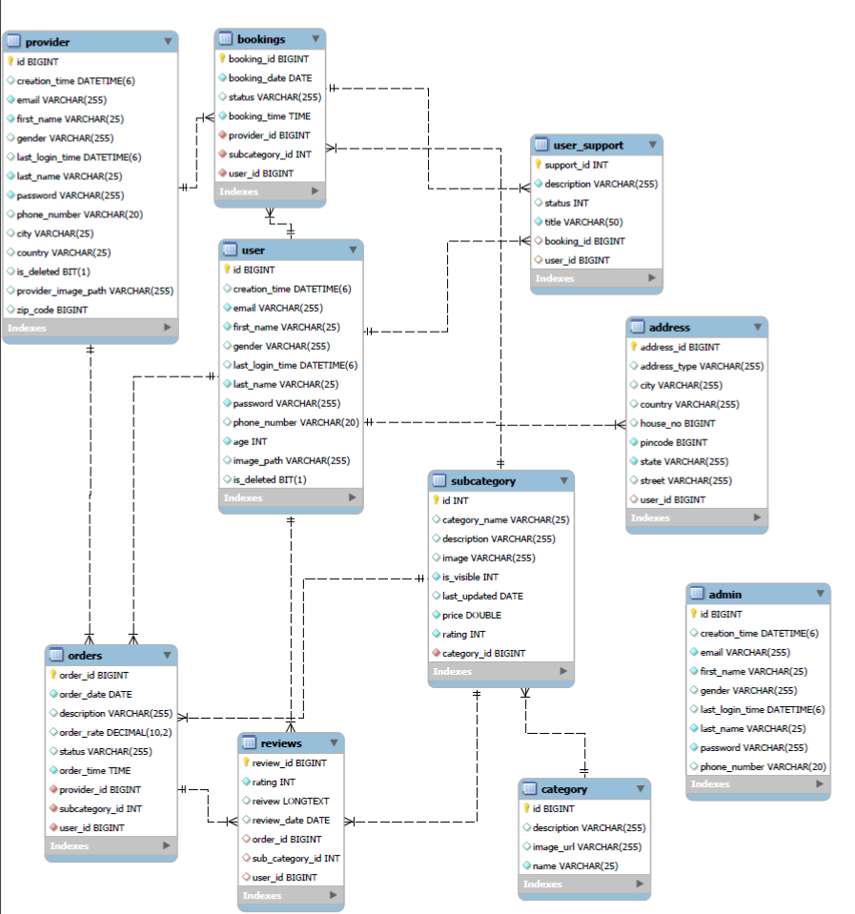

Appendix B

Homepage: 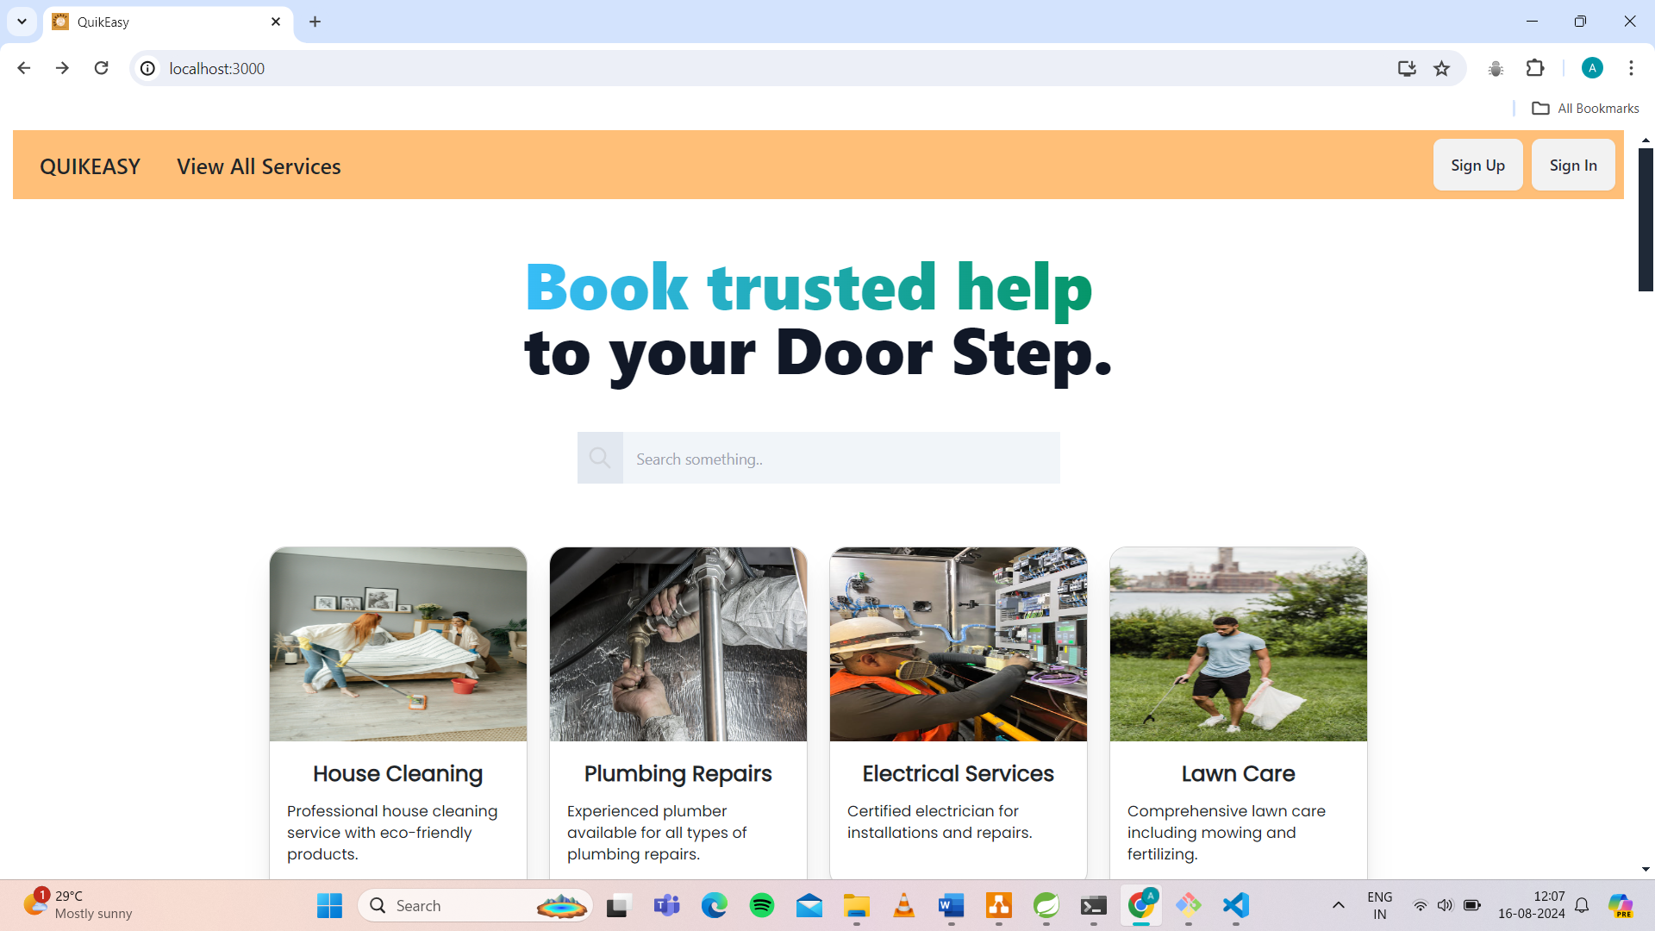

LoginPopup: 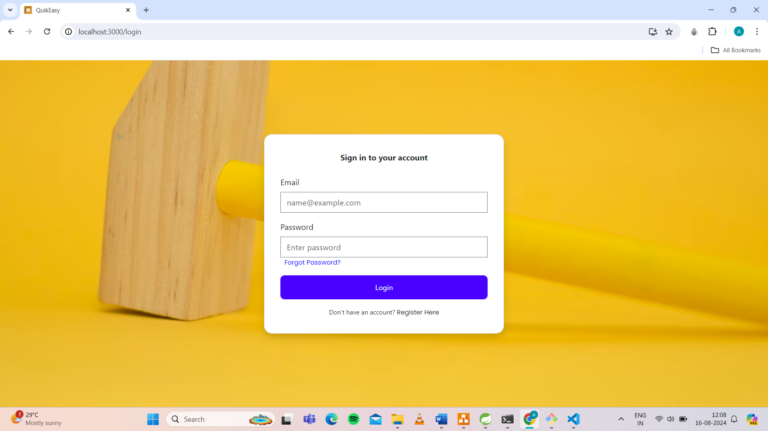

Administrators Login:

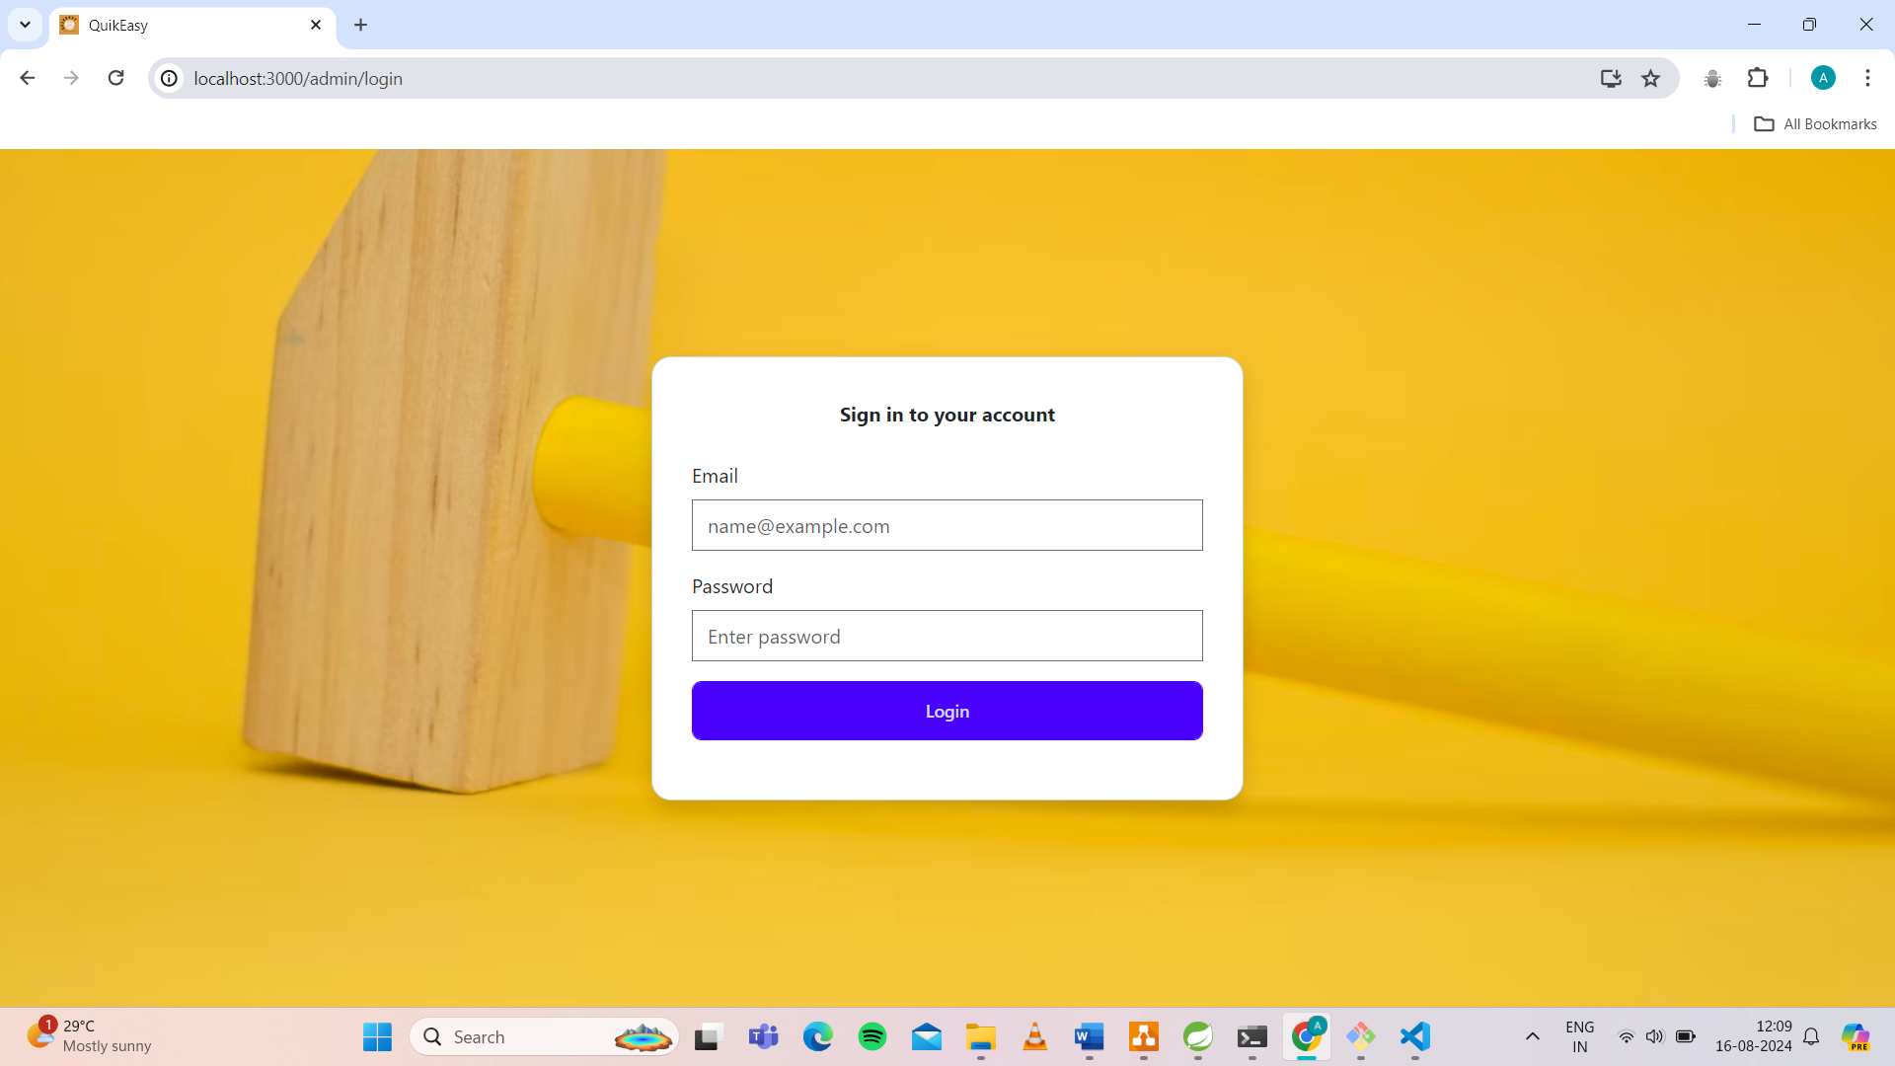

Provider Login:

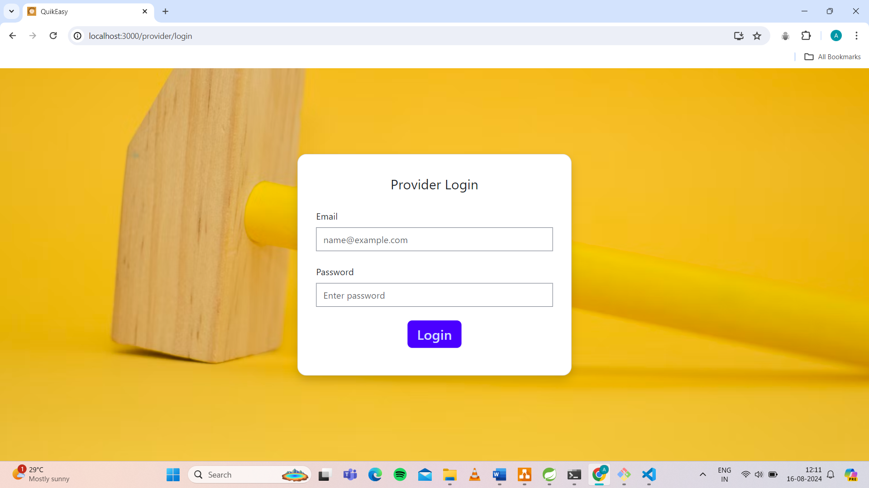

User Registration:

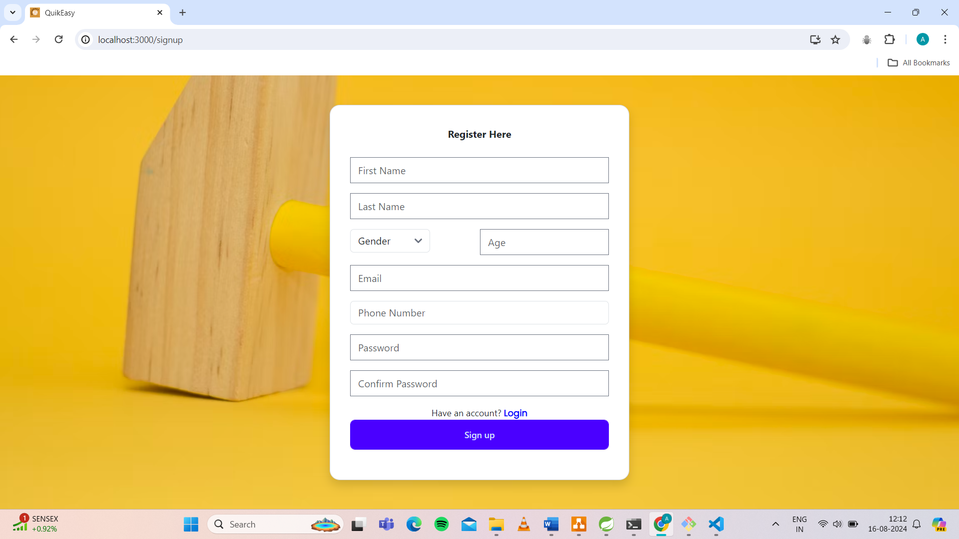

**View All Service**

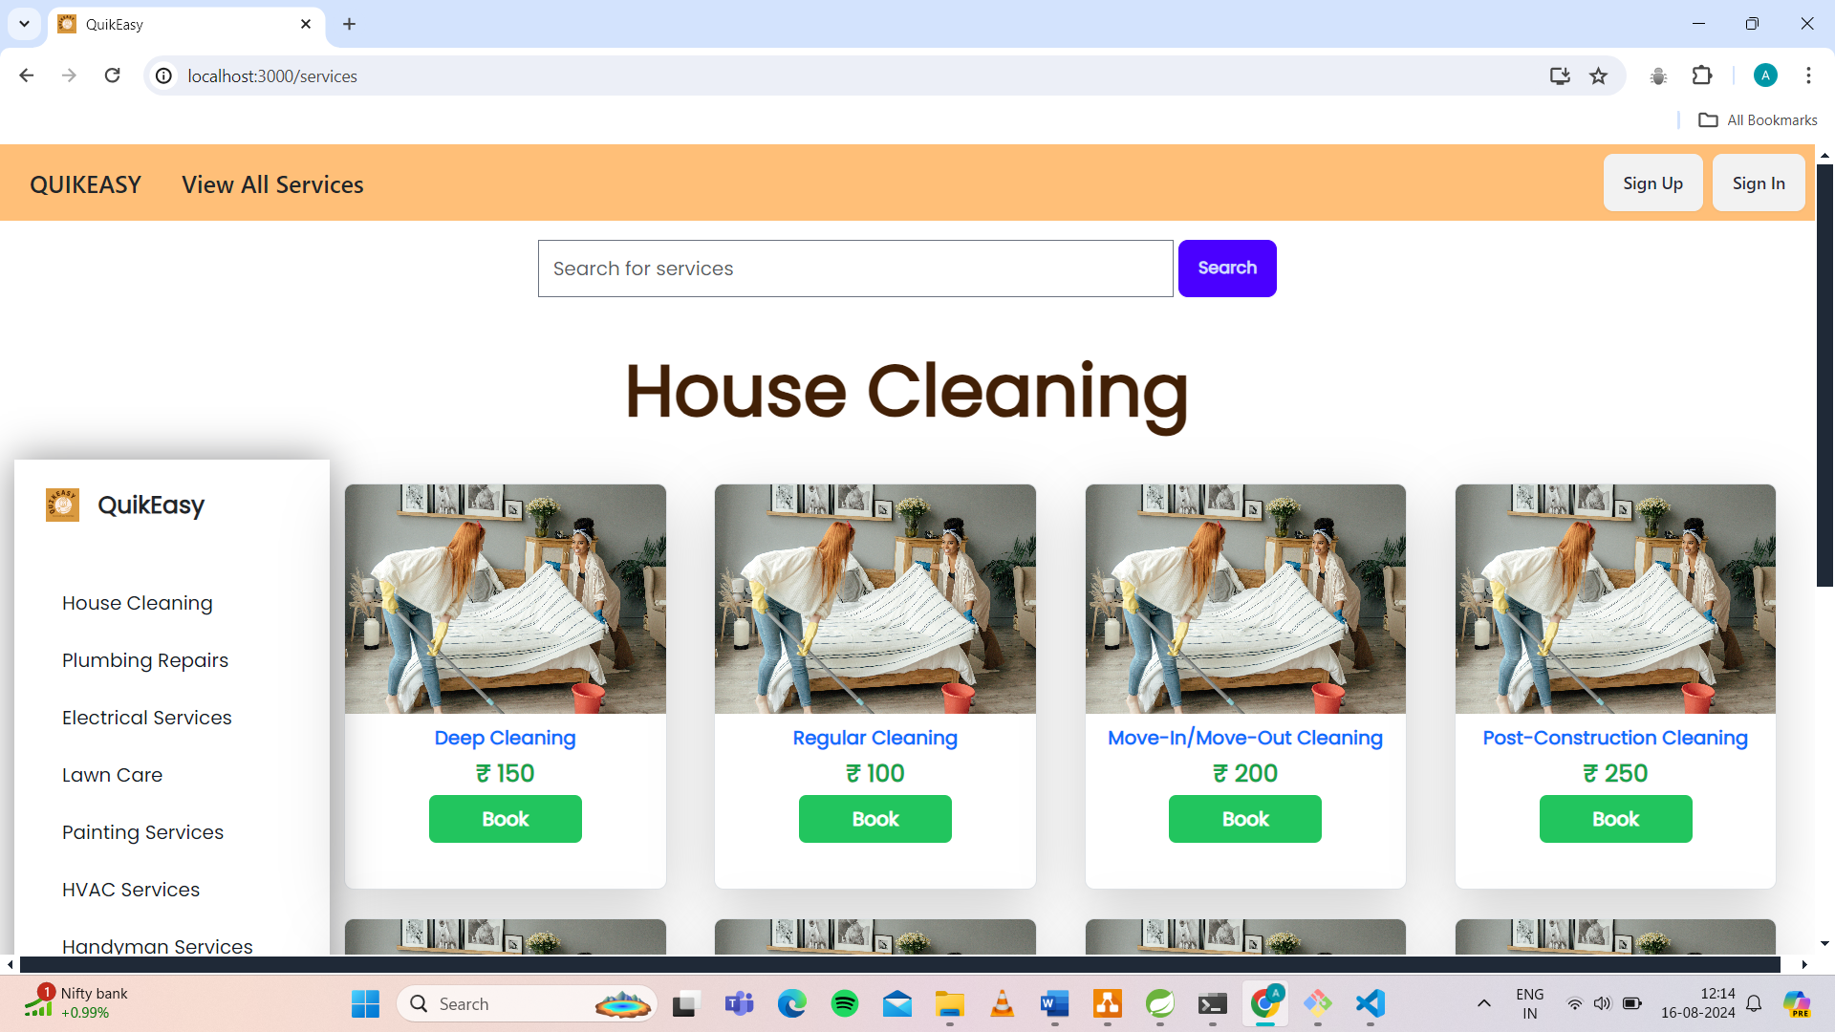

**Contact** 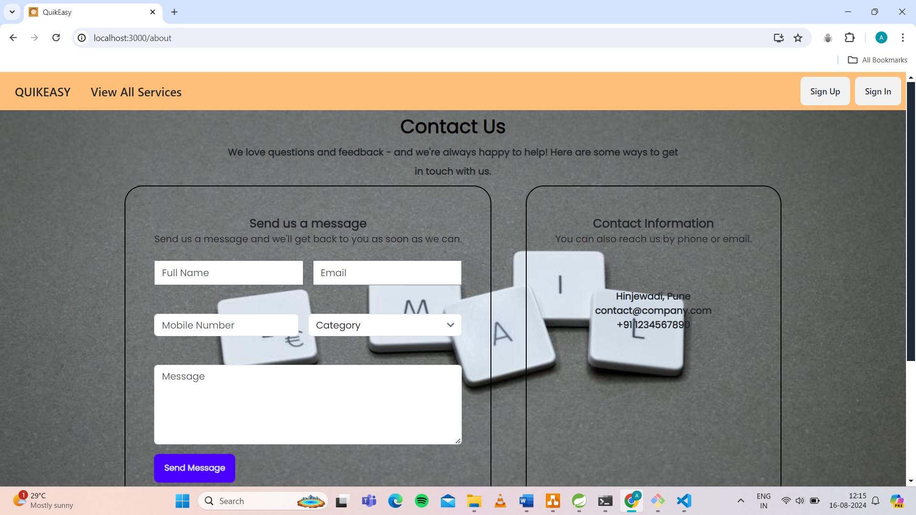

**Review**

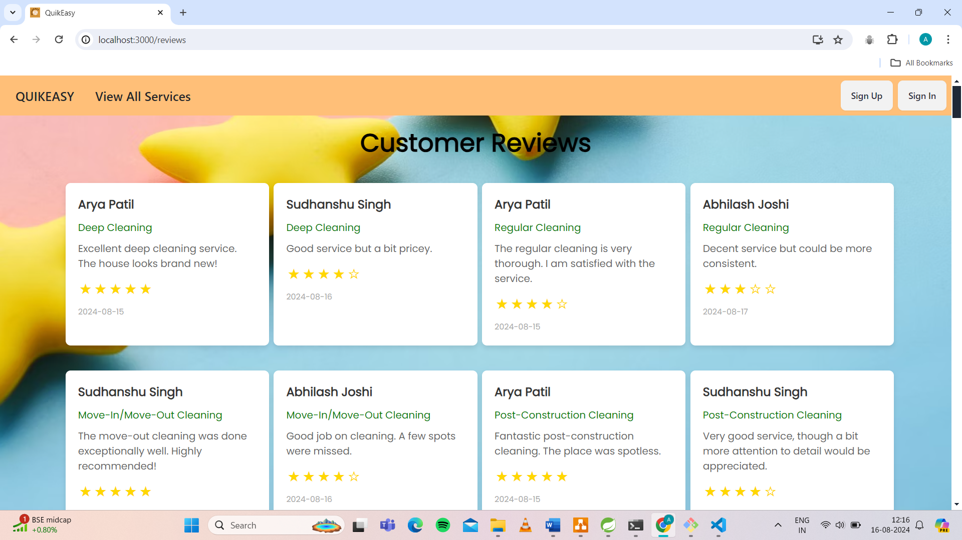

**UserDetails:**

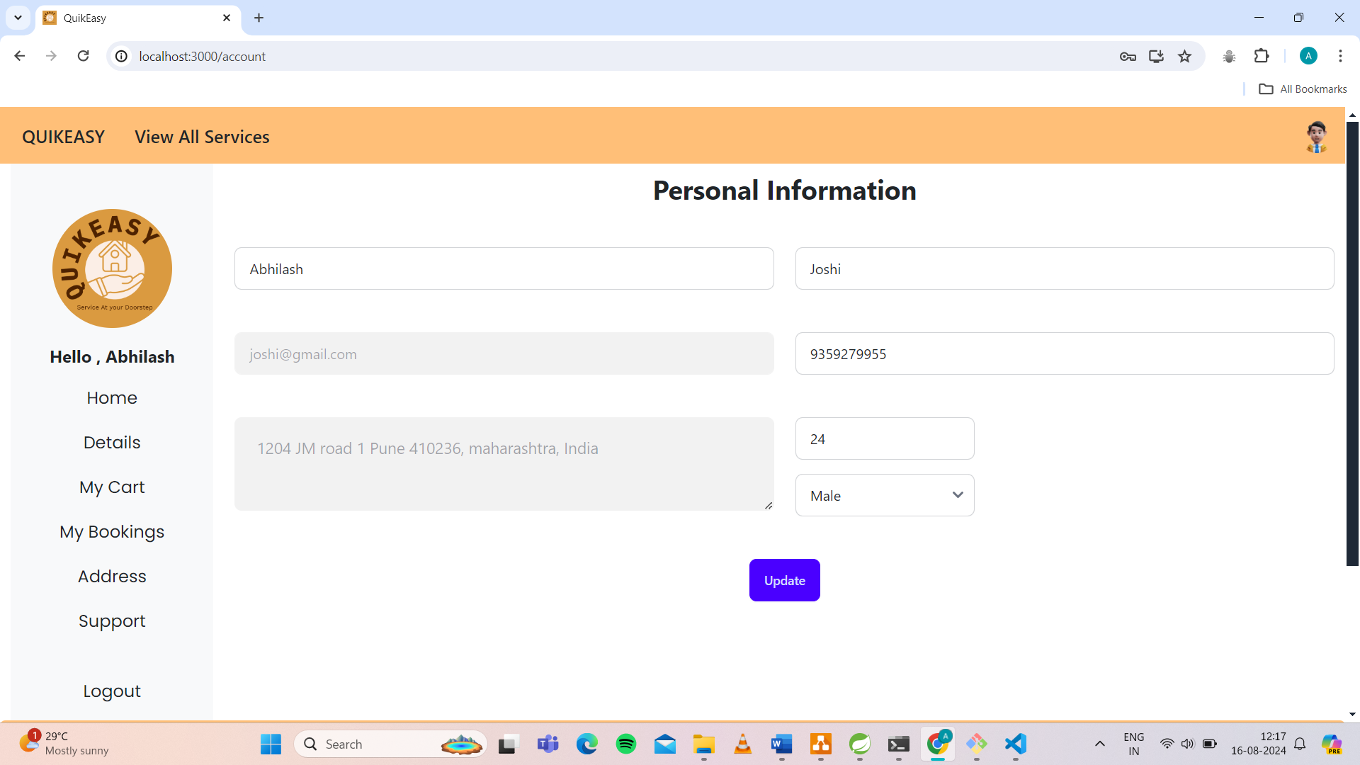

Cart: 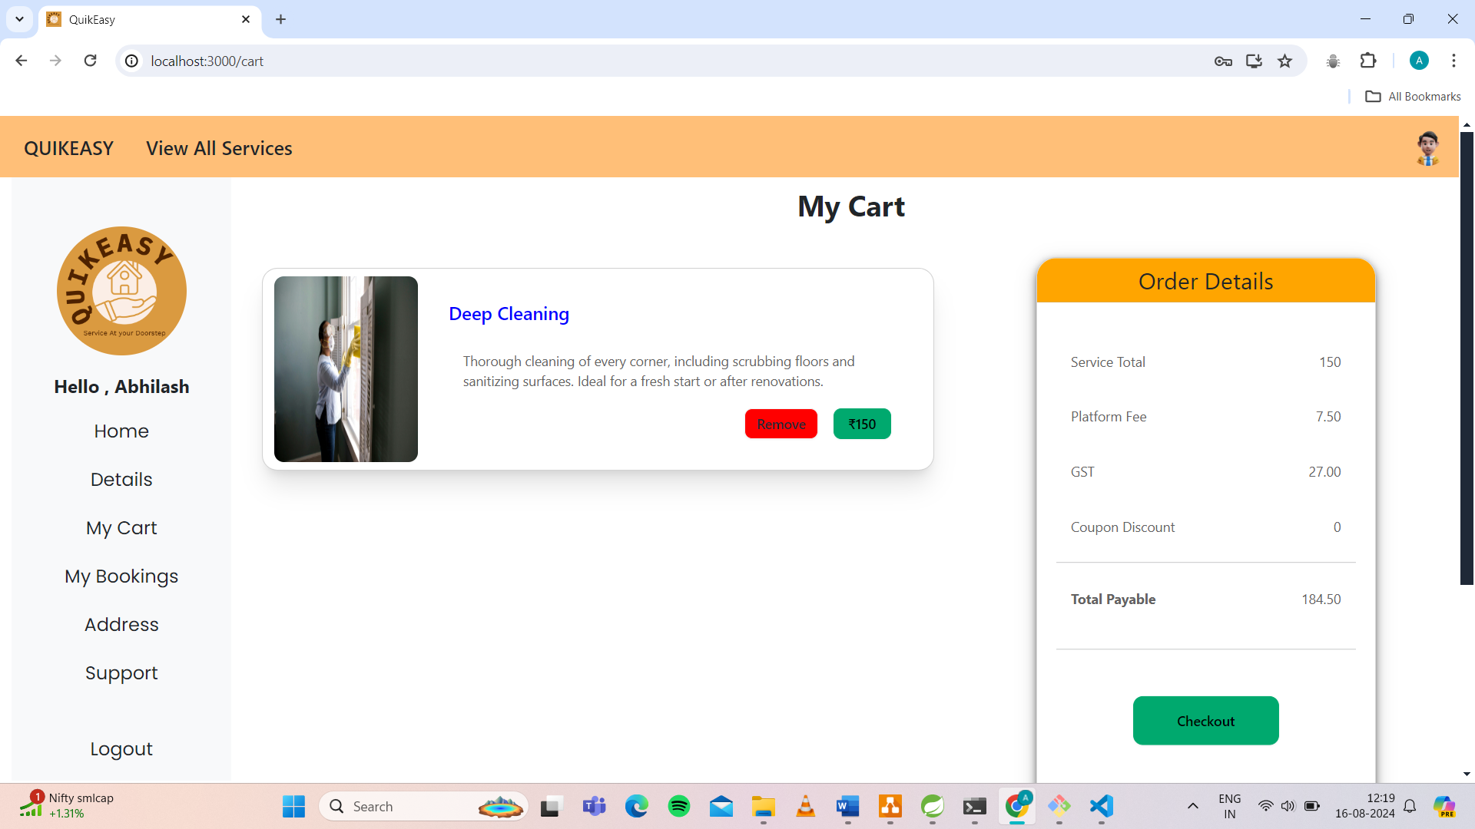

CurrentBookings:

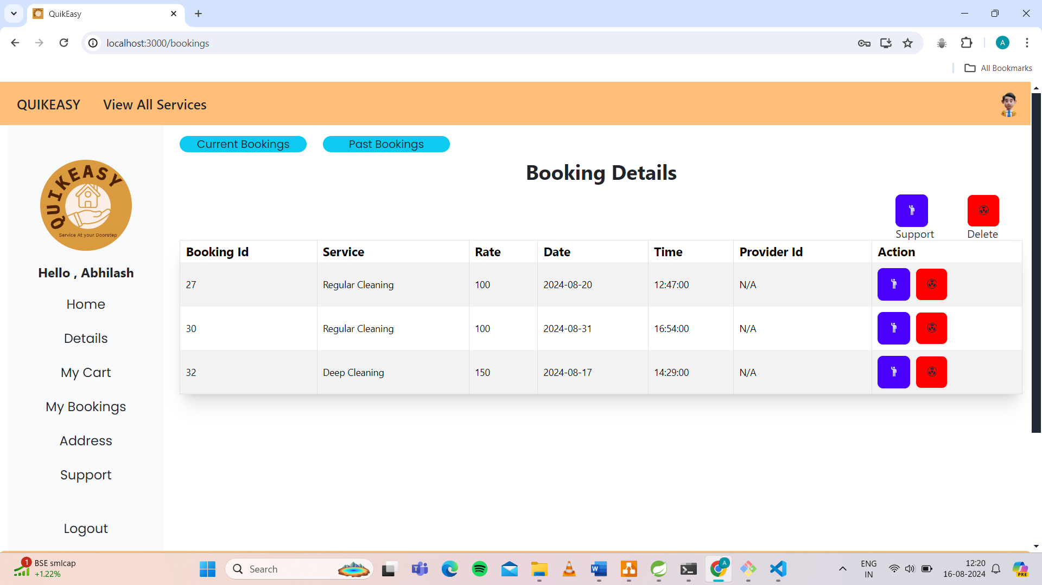

PastBookings: 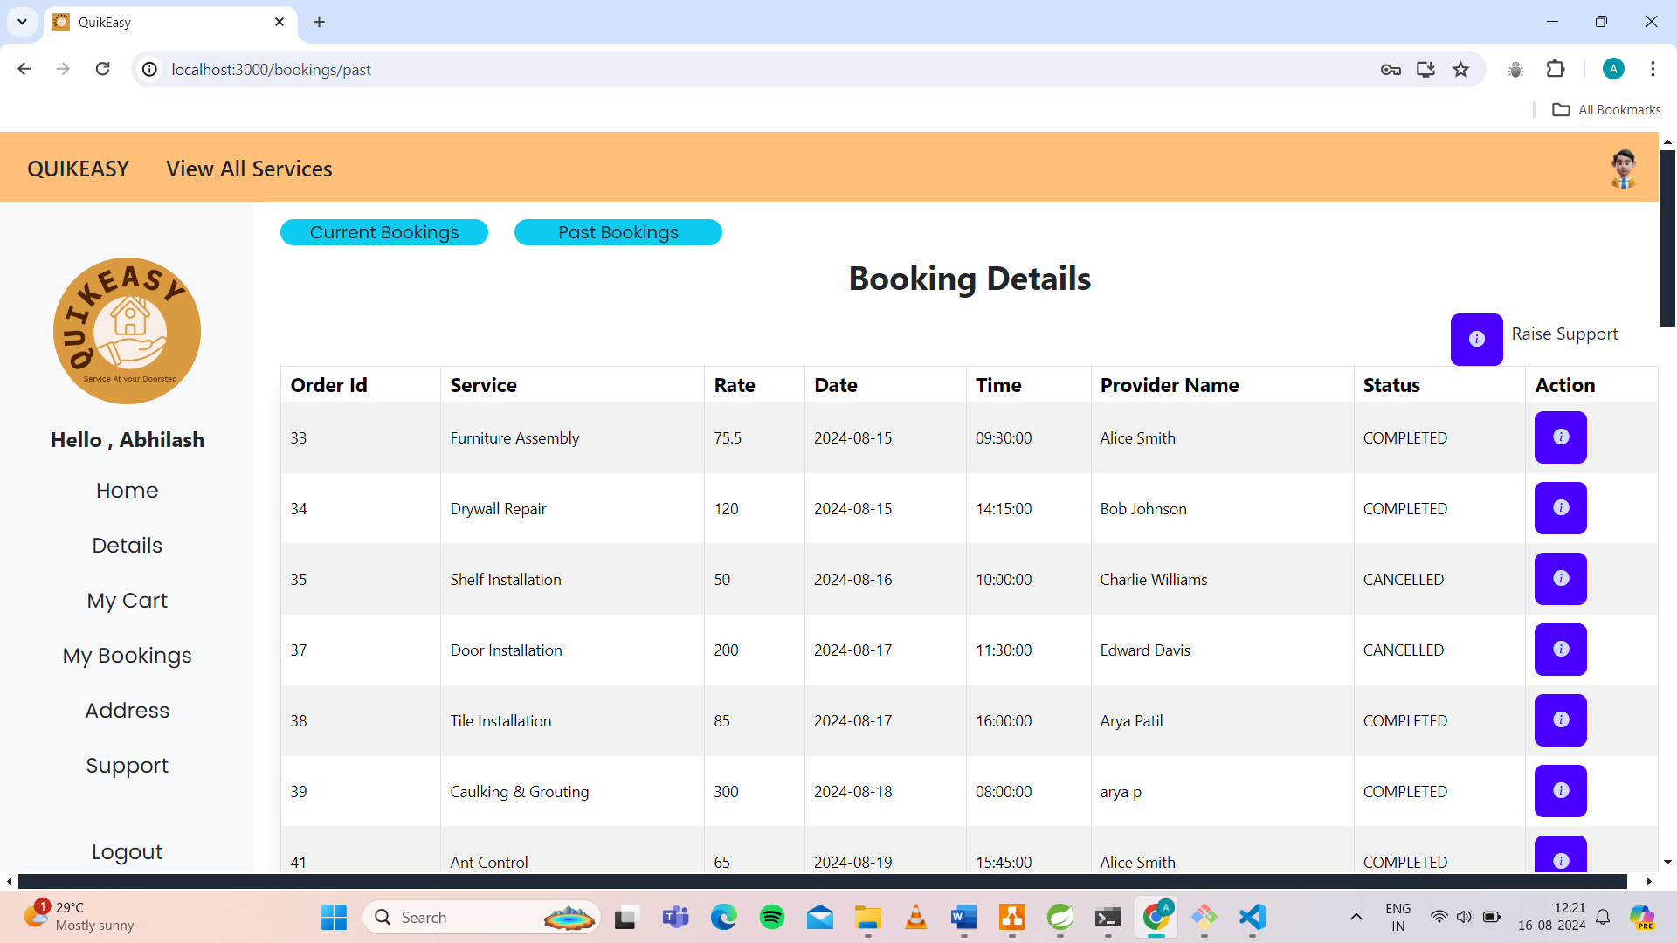

Address: 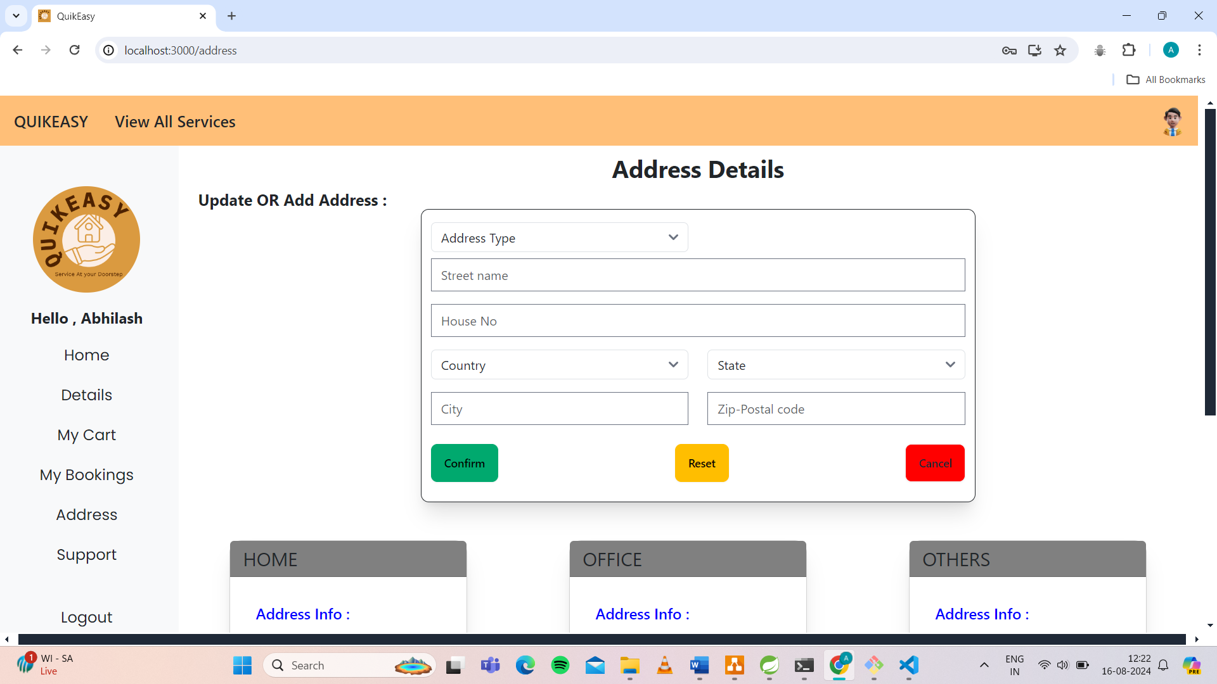

**SheduleBooking:**

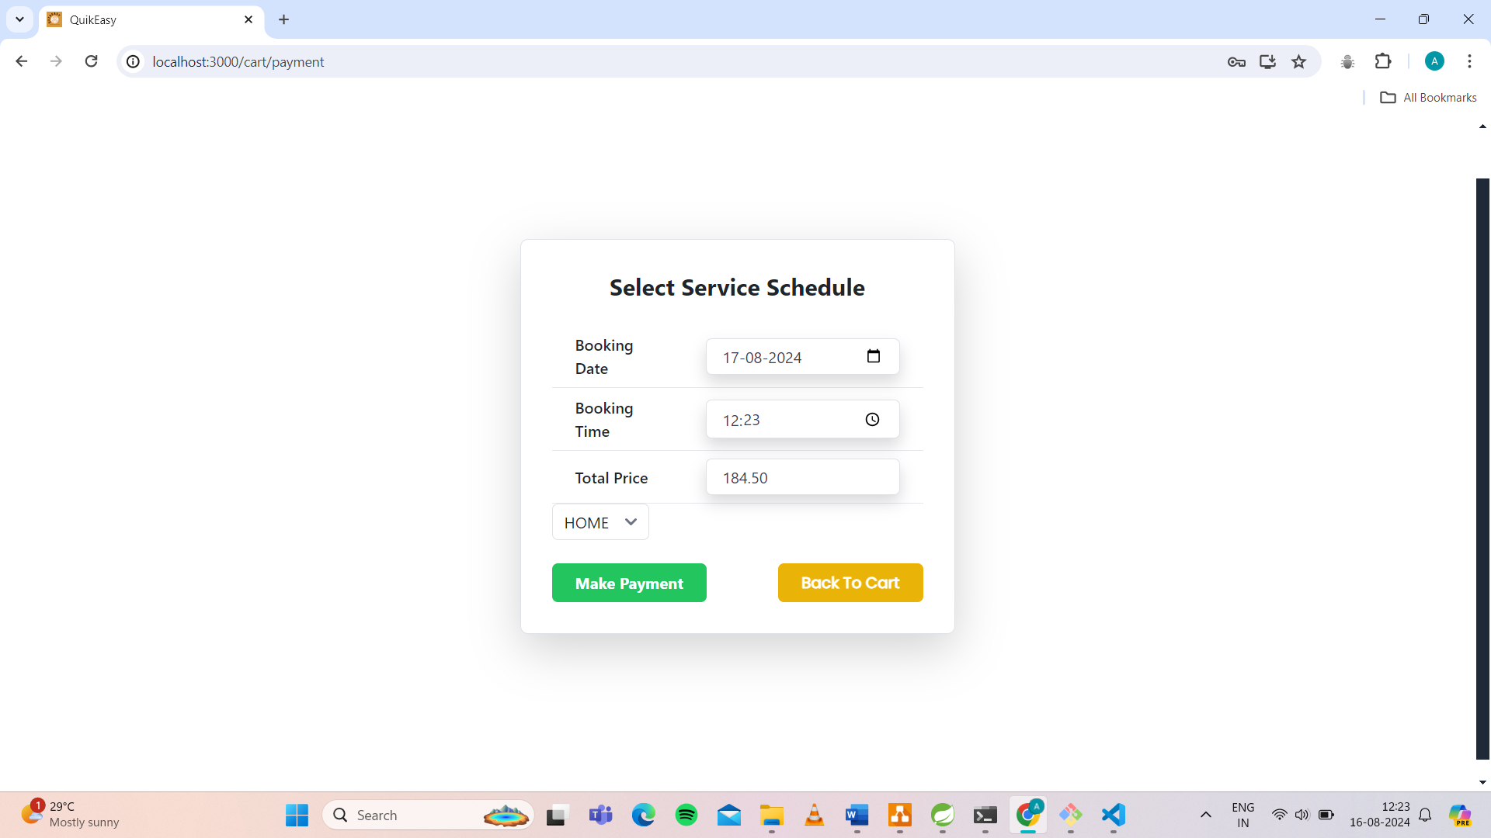

**OrderDetails:** 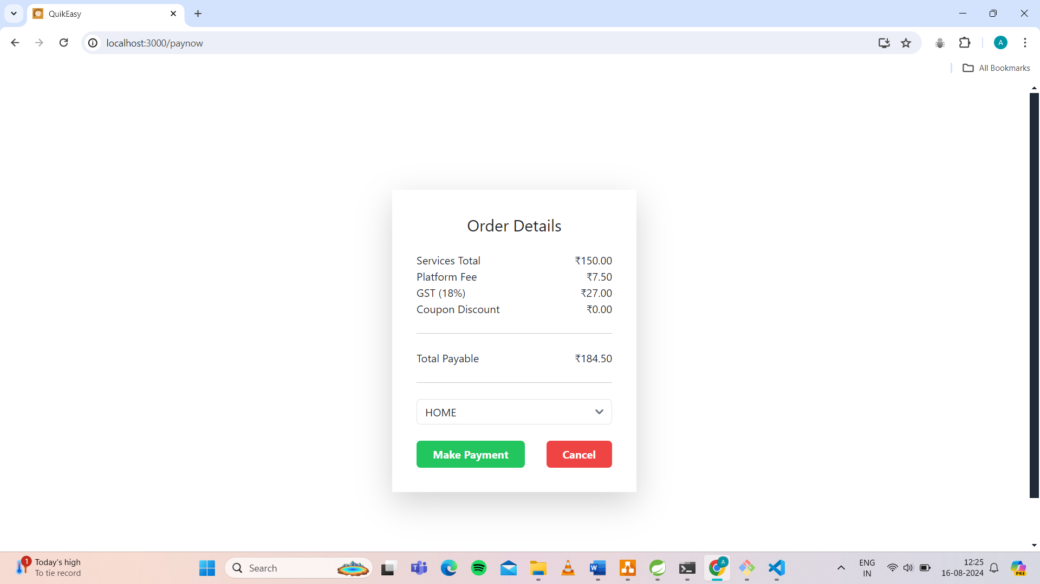

**SubcategoryDetails:**

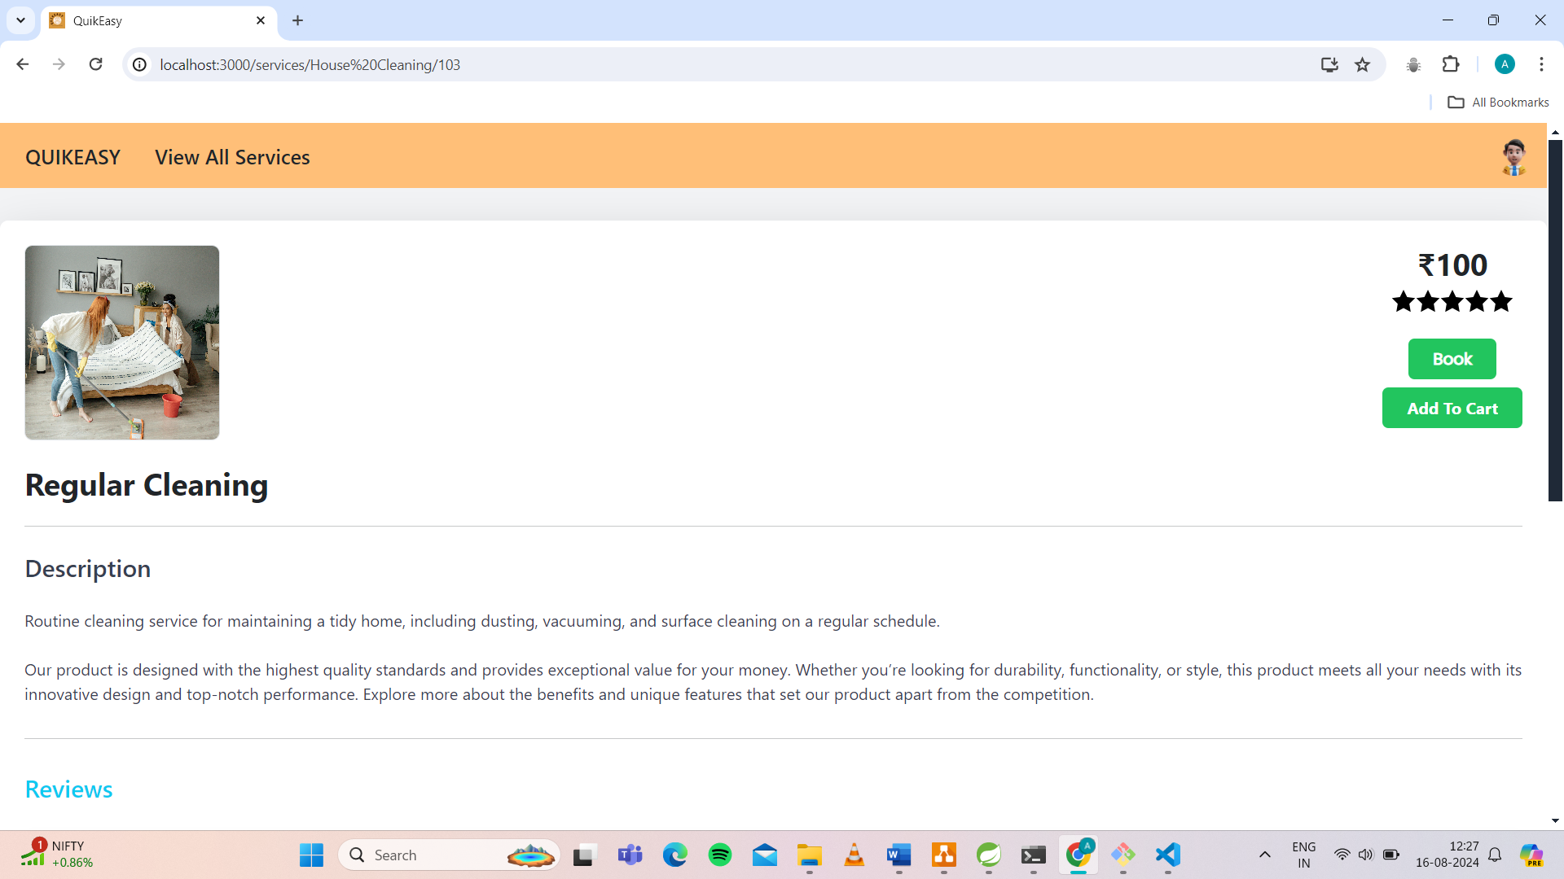

**ProviderDashboard:**

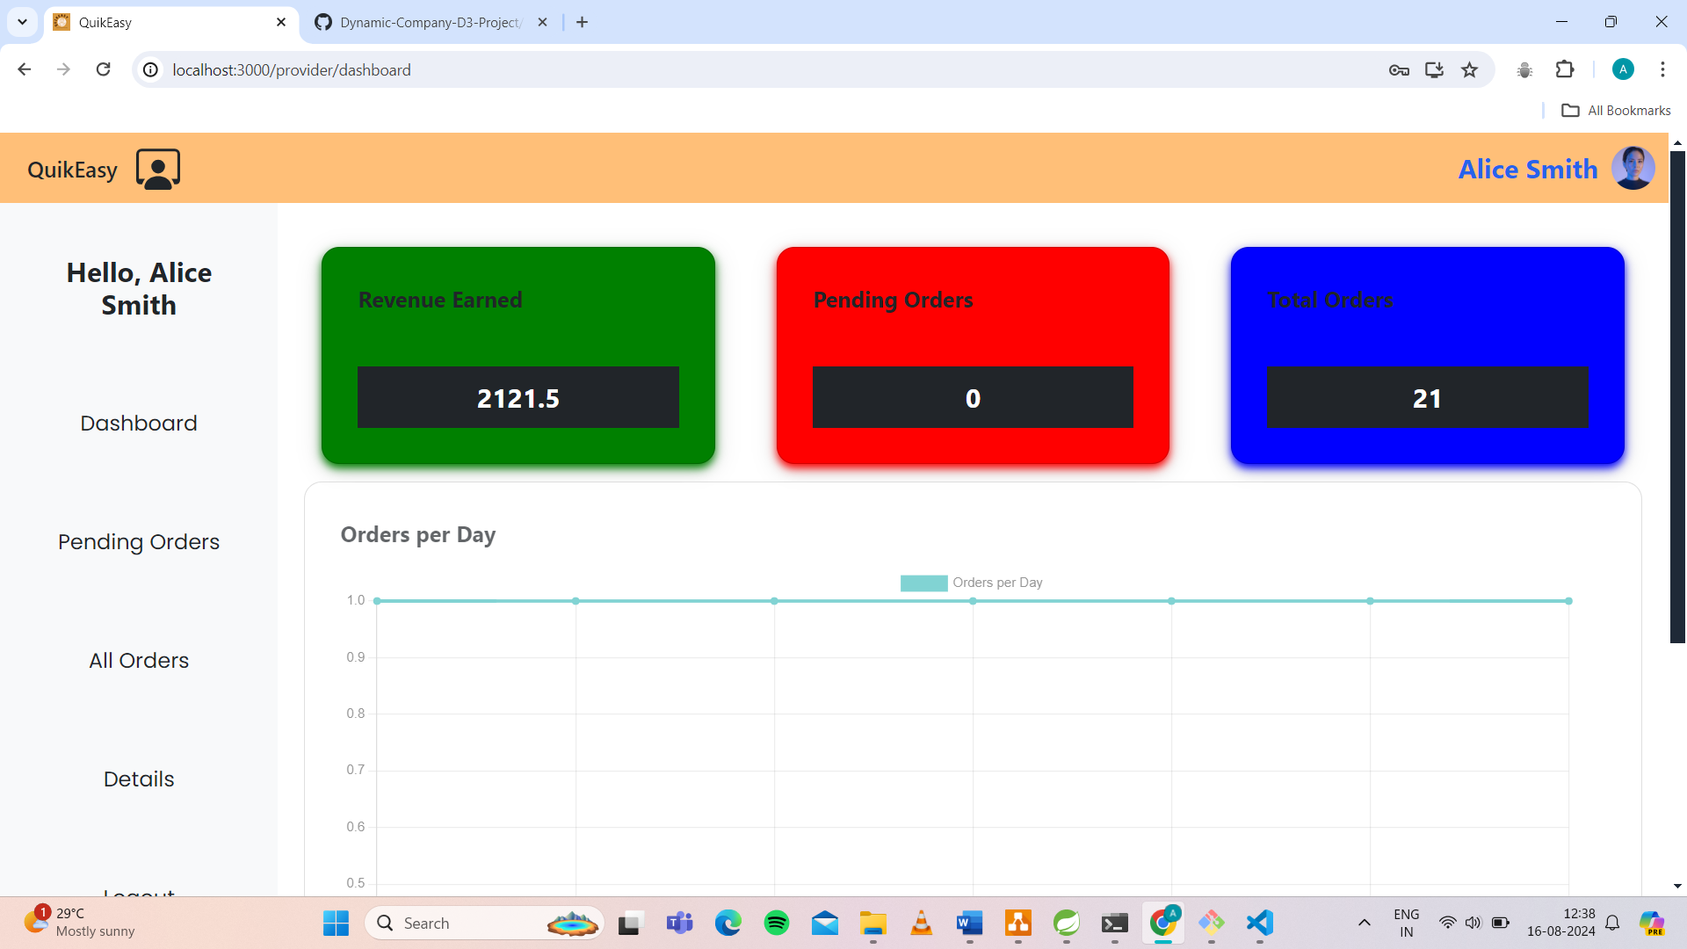

**ProviderPendingOrders:**

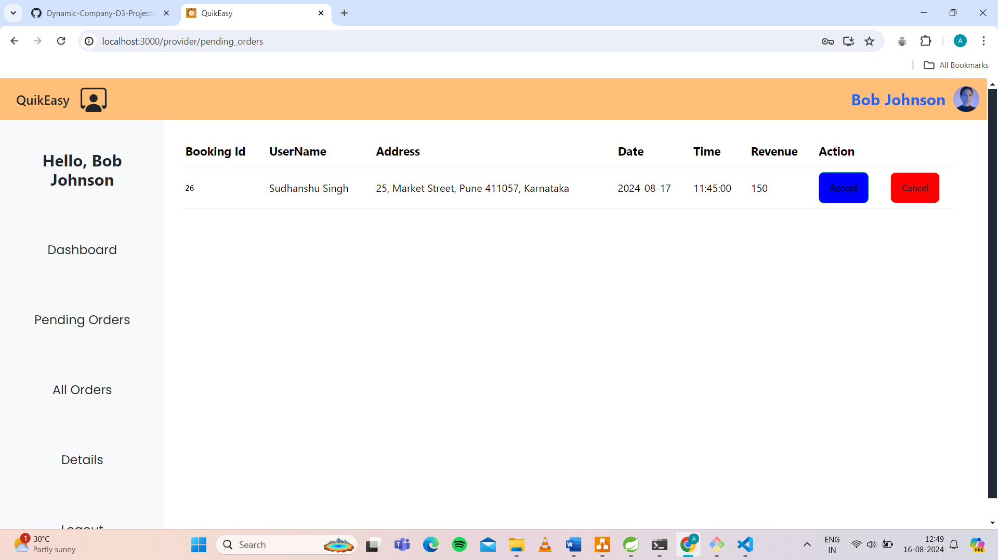

**ProviderAllOrders:**

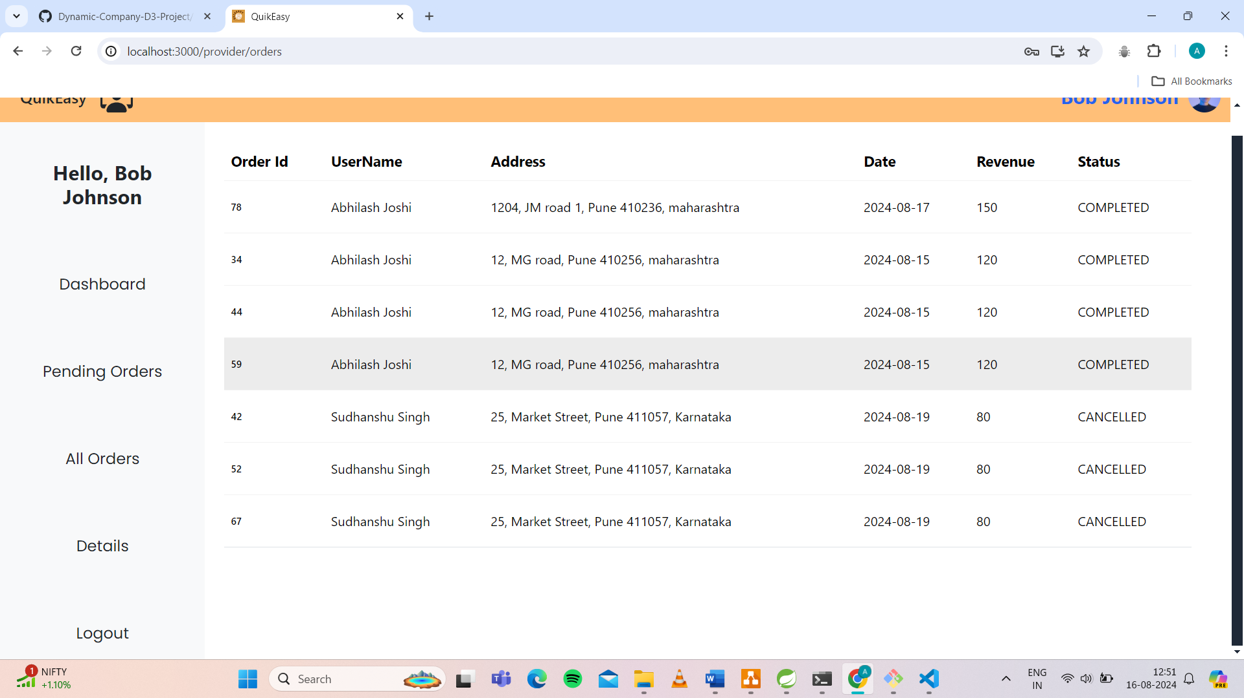

**ProviderDeatils:**

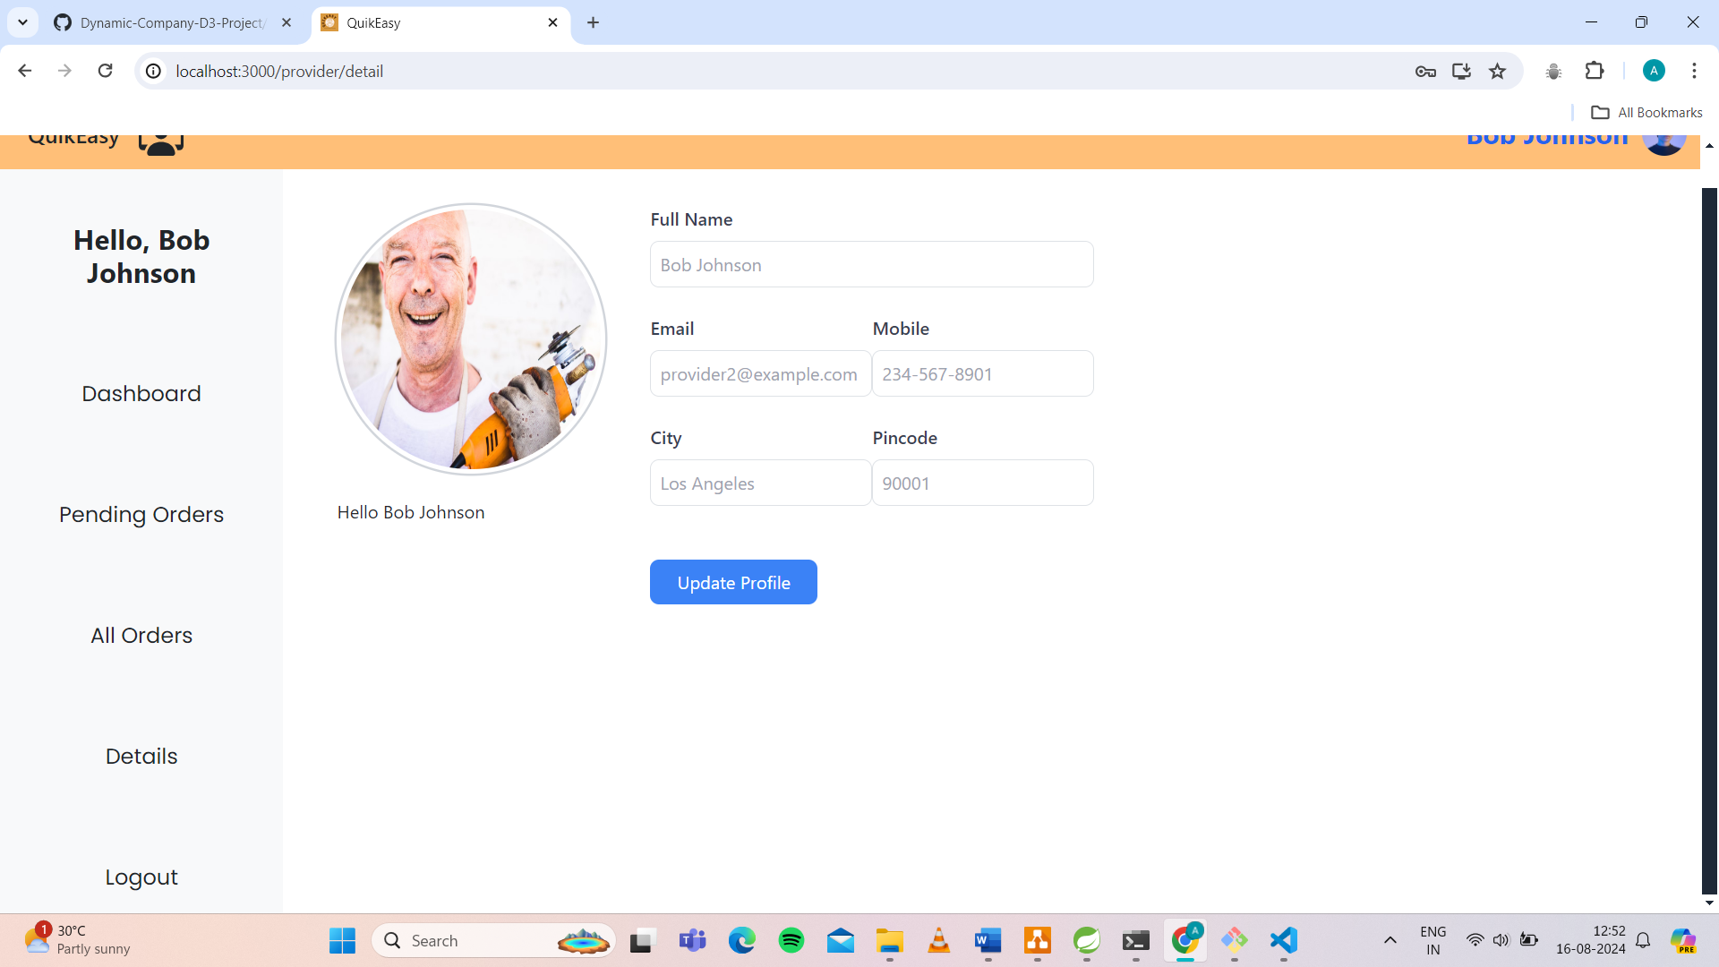

**AdminDashboard:**

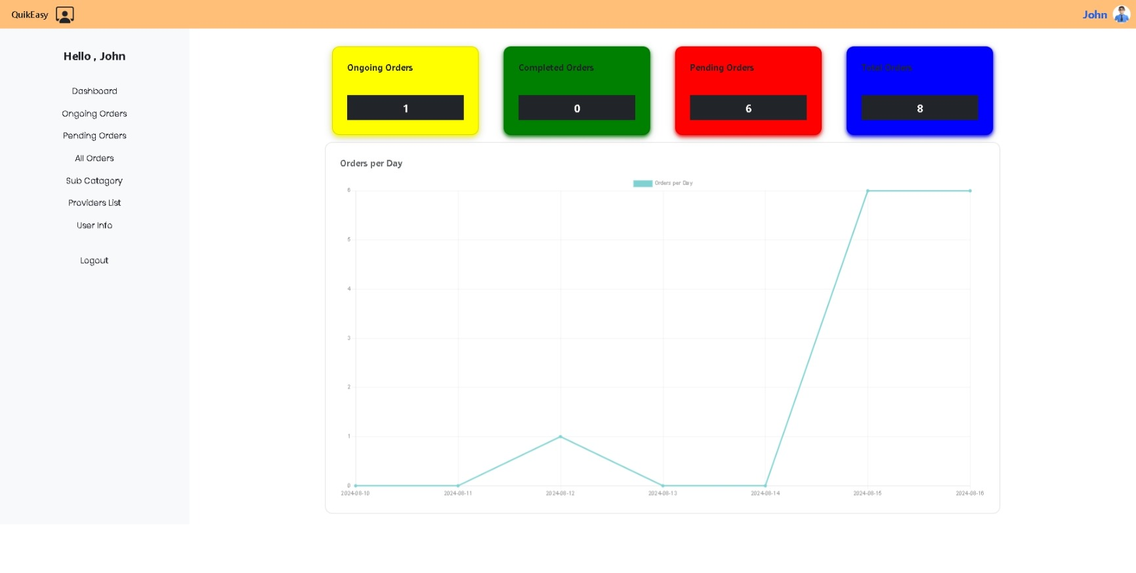

**AdminOngoingOrders:**

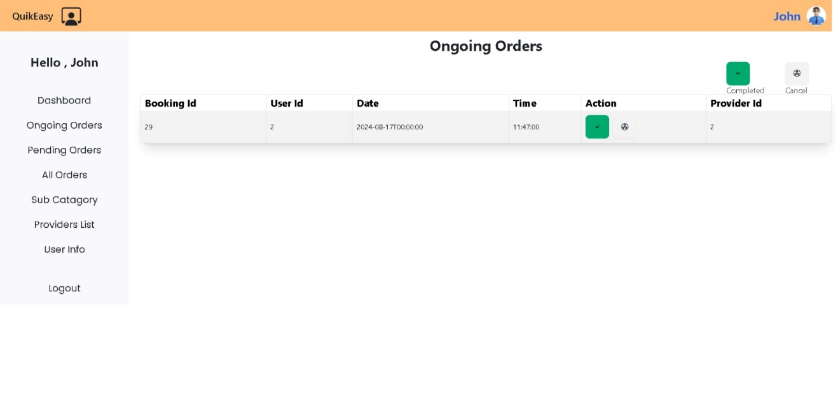

**AdminPendingOrders:**

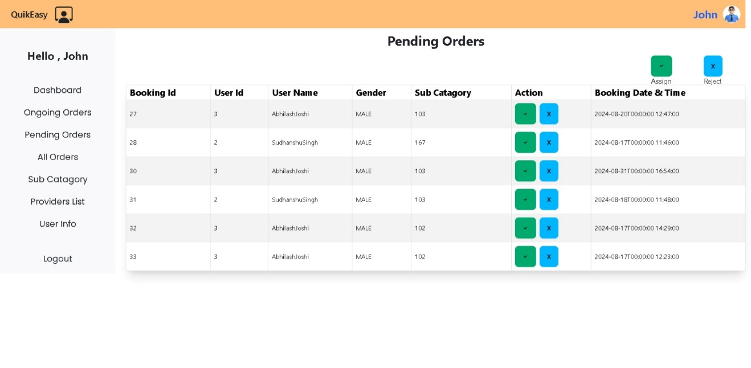

**ProviderListAnd Add provider:**

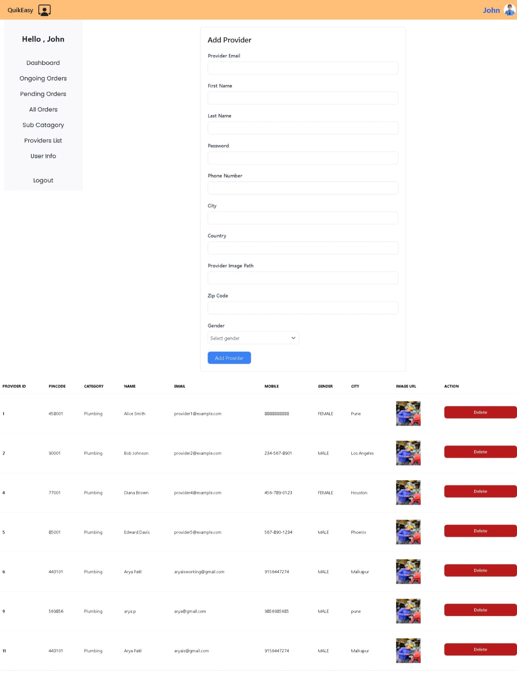

**UserList:**

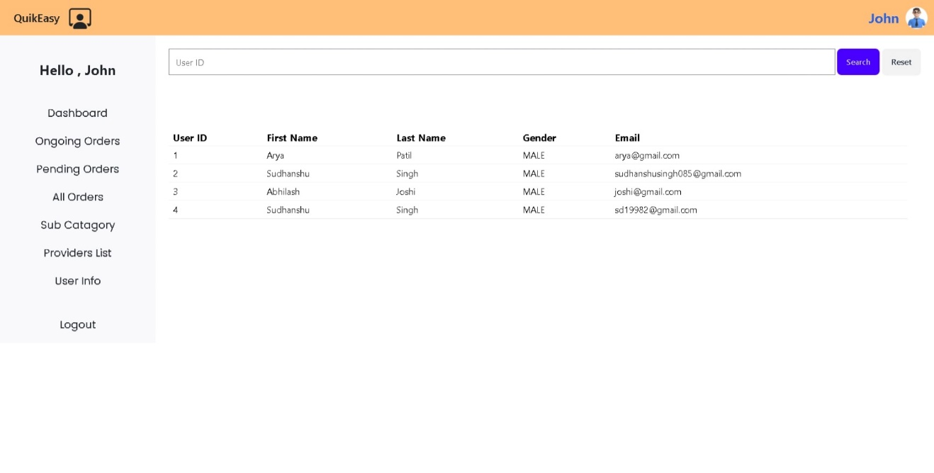

**7.REFERENCES:**

<http://www.google.com>

https://www.urbancompany.com/pune

https://www.airbnb.co.in/

https://www.angi.com/

https://www.oracle.com/in/java/technologies/java-ee-glance.html

http://www.wikipedia.org

https://getbootstrap.com/

https://www.handy.com/